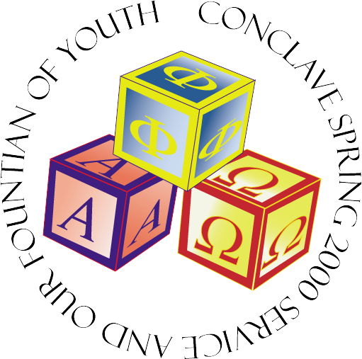

Welcome!!!!!

We are glad you made it here, and can’t wait to get this weekend underway. OI has been working really hard getting ready for this awesome time of service and friendship. We hope you enjoy your stay. So sit back, relax and then do some work! Any questions: ask the confused looking guy. And remember, no matter what happens, I didn’t do it!

YiLFS,
Jen ☺

Schedule

Friday
Time What Place

6 pm – Midnight Registration Alumni Gym
8 pm – Midnight Romper Room Lower Wedge/Quad
Midnight Welcoming Address Lower Wedge
Midnight – Mornin’ Attempt to Sleep Alumni Gym

Saturday
7:30 AM Wake up!!! Alumni Gym
7:30 - 8:30 Breakfast Lower Wedge
8:30 – 11:30 Service Projects various
9:00 – 5:00 LDW Morgan A
11:30 – 1:30 Lunch Lower Wedge
12:30 – 2:00 Section meetings 94 – Higgins 114
96 – Higgins 116
1:30 –5:00 Workshops Galore Higgins Labs
2:00 – 3:00 Joint meeting Higgins 116
5:00 – 7:00 Naptime! Alumni Gym
6:30 Mingling/seating Alden Hall
7:00 Dinner served Alden Hall
7:00 – 7:30 SHM Performance Alden Hall
8:00 – 9:00 Awards, Speeches, Role Call Alden Hall
9:00 Dancin’, Dancin’, Dancin’ Alden Hall
1:00 (in the mornin’) Attempt to sleep some more Alumni Gym

Sunday
8:30 Breakfast Lower Wedge
10:00 Good bye’s Quad

Service locals

*Car Wash
Meet on the quad.
Car wash to raise money to benefit a children’s daycare center near campus. We hope to get them a shed to store outside play toys for the children.

*Kids Tournament
Meet in from of Alumni Gym
Children ages 6-15 from a local shelter will participate with “big brothers” in a game tournament.

*Veterans’ Shelter
Meet at the ATM machine outside the Wedge.
Assist with various cleanup and projects at the nearby Veterans’ Shelter.

*Quinnsigamond Village Cleanup
Meet in front of Alden Hall.
TBA

*Card Making for Kids
Meet in the Lower Wedge
Make Easter and get well card for children at various long term care hospitals.

workshop locals

Session 1 (1:30 – 2:45)
Kara Ploof
Service Roundtable
Room 218

Jen Hardy
Pledge Roundtable
Room 154

Jonathan Oexner
Fellowship Roundtable
Room 114

Rick “Satan” Quottamine
Membership 101
Room 202

Session 2 (3:00 – 4:00)
Brotherhood 401:Advanced Concepts in Brotherhood
Marilyn Mims
a look at brotherhood from the other view. We spend a great deal of time
on building pur pledging programs. THis workshop focuses on building our
brotherhood. In this workshop, you will hoepfully find new ways ofg
looking at and promoting RETENTION! A must for anyone willing to
strengthen their bonmds of brotherhood.
Room 114

Cheryl Smith
Workshop : Membership - Large chapters "GROWING PAINS"
A look at how to maintain a chapter with a large brotherhood.
Room 116

Craig Muckle
The C.Muckle Special
Room 202

Steve Merril
Room 218
Selling APO to your Campus

Session 3 (4:00-5:00)
Nina Simon and Tim Hogan
Learn Tai Chi
Room 154

Simon Nance
Room 202
Learn how to do ice breakers when to get to know perspectives and pledges

Room 114
Finger-painting: let’s see if we can cheer up those kiddies!

Katie Bouffard & Vicky Wu
Alumni Gym (where ya slept last night)
Ball room dancing, or some other styles too!!! You too can learn!!

